**WATERWISE+: REAL-TIME WATER CONSUMPTION MONITORING AND BILLING APPLICATION FOR RESPONSIBLE WATER USAGE AND COST TRANSPARENCY USING IOT**

A Research Paper in

CAPSTONE PROJECT

Presented to the Faculty of School of Computer Studies

University of San Jose – Recoletos, Basak Pardo, Cebu City, Philippines

In Fulfillment

of the Requirements of the Degree of

Bachelor of Science in Information Technology

**Punay, Ella Venice C.**

**Filosopo, Earl Michael M.**

**Pintor, Timmy John T.**

**February 2023**

**Table of Contents**

**CHAPTER I** ……………………………………………………………………………… 1

**INTRODUCTION** ……………………………………………………………………. 3

Rationale of the Study ………………………………………………………….. 3

**THEORETICAL BACKGROUND** …………………………………………………. 4

**REVIEW OF RELATED LITERATURE** ……………………………….………….. 7

**PROJECT OBJECTIVE** ……………………………………………………………. 9

Project Scope and Limitations …………………………………………………. 9

**CHAPTER II** ……………………………………………………………………………… 11

**SOFTWARE REQUIREMENTS AND DESIGN SPECIFICATIONS** …………… 11

Application Overview ……………………………………………………………. 11

Architecture Diagram ……………………………………………………………. 12

Use Case Diagram ……………………………………………………………… 14

Use Case Narratives ……………………………………………………………. 16

Activity Diagram………………………………………………………………….. 22

UML Class Diagram …………………………………………………………….. 27

User Interface and User Experience Design …………………………………. 28

**CHAPTER I**

**INTRODUCTION**

**Rationale of the Study**

Water scarcity and inefficient water management practices are pressing concerns worldwide [1]. Water resources are becoming increasingly strained due to population growth, urbanization, and climate change [2], which has led to a critical need for innovative solutions that promote responsible water usage and efficient water management. In light of these challenges, this study aims to develop a real-time water monitoring app using IoT technology to empower households in monitoring their water consumption, fostering a deeper understanding of usage patterns, and promoting water conservation.

Traditional methods of water usage monitoring rely on manual readings and periodic billing cycles, offering limited insights into real-time consumption patterns. Such conventional approaches often result in delayed detection of leaks, difficulty in identifying areas of water wastage, and lack of transparency in billing. Additionally, manual data collection is time-consuming [2], prone to errors, and provides minimal opportunities for user engagement. These limitations underscore the need for an alternative solution that leverages advanced technologies to enable accurate, timely, and user-friendly water monitoring.

The existing gap lies in the absence of a comprehensive and accessible system that empowers households to actively monitor their water consumption and address the challenges posed by inefficient water management. The lack of real-time data and personalized insights inhibits users' ability to make informed decisions about their water usage and identify opportunities for conservation. Furthermore, the limited integration of IoT technology in water monitoring hinders the potential for efficient leak detection, early intervention, and effective resource allocation.

To bridge the identified gap, this study proposes the development of a real-time water monitoring app that harnesses the power of IoT technology. The app will seamlessly integrate with IoT-enabled water meters or sensors installed in households, providing users with accurate and up-to-date data on their water consumption. Through personalized analytics, notifications, and recommendations, users can gain valuable insights into their usage patterns, detect potential leaks, and adopt more responsible water usage habits. By empowering households with real-time monitoring and actionable information, the proposed solution aims to foster a culture of water conservation, enhance transparency in billing, and contribute to sustainable water management practices.

**THEORETICAL BACKGROUND**

**Water Consumption and Management**

Water consumption and management are critical factors in ensuring the sustainable use of water resources. Effective monitoring and management of water consumption play a key role in promoting responsible water usage and conservation. Traditional methods of water monitoring often rely on manual readings and periodic billing, which can result in delayed detection of leaks, inaccurate billing, and limited awareness of real-time water usage patterns. To address these challenges, technological advancements, such as Internet of Things (IoT) and real-time monitoring systems, have emerged as potential solutions to improve water consumption tracking and management.

**Internet of Things (IoT) in Water Monitoring**

The Internet of Things (IoT) refers to a network of interconnected devices that can collect, exchange, and analyze data [5]. In the context of water monitoring, IoT technology enables the integration of sensors, meters, and devices to monitor water consumption in real-time. IoT-enabled water monitoring systems provide accurate and up-to-date data on water usage, allowing users to track their consumption patterns, identify areas of potential waste, and make informed decisions to optimize their water usage. By leveraging IoT technology, water monitoring becomes more efficient, enabling early detection of leaks, proactive intervention, and improved resource management.

**Real-Time Water Monitoring Apps**

Real-time water monitoring apps leverage IoT technology to provide users with real-time data on their water consumption. These apps often integrate with IoT-enabled devices, such as water meters or sensors, to collect and transmit data on water usage to a central database. Users can access this information through the app, which offers personalized analytics, visualizations, and notifications. Real-time water monitoring apps empower users to actively monitor and manage their water consumption, promoting responsible usage, identifying opportunities for conservation, and facilitating behavior change towards more sustainable water practices.

**Benefits of Real-Time Water Monitoring Apps**

Real-time water monitoring apps offer several benefits in promoting responsible water usage and efficient water management:

**Enhanced Awareness:** Users gain real-time insights into their water consumption, fostering awareness and understanding of usage patterns. This awareness encourages users to adopt water-saving practices and make informed decisions to conserve water.

**Leak Detection and Prevention:** Real-time monitoring allows for early detection of leaks or abnormal water consumption patterns. Timely identification of leaks enables prompt repairs, minimizing water wastage and associated costs.

**Personalized Recommendations:** Real-time water monitoring apps can provide personalized recommendations based on user consumption patterns. These recommendations may include water-saving tips, usage benchmarks, and conservation strategies tailored to individual needs.

**Cost Transparency:** By providing users with detailed information on their water consumption, real-time water monitoring apps enhance cost transparency. Users can accurately track their usage and have a clearer understanding of their water bills, promoting accountability and cost-effective water management.

**Data-driven Decision Making:** Real-time water monitoring apps generate comprehensive data on water usage trends, consumption patterns, and potential areas of waste. This data can inform policy decisions, infrastructure planning, and resource allocation to optimize water management strategies at the community or municipal level.

In summary, the theoretical background of this study revolves around the concepts of water consumption and management, IoT technology in water monitoring, real-time water monitoring apps, and the benefits they offer. By exploring these theoretical foundations, this study aims to develop a real-time water monitoring app that leverages IoT technology to empower households in monitoring and managing their water consumption, promoting responsible usage, and contributing to sustainable water management practices.

**REVIEW OF RELATED LITERATURES**

Water scarcity and inefficient water management practices have become pressing global concerns [1]. To address these issues, researchers have explored the development of smart water monitoring systems using IoT and cloud computing technologies. These systems aim to provide real-time visualization of water consumption, detect leaks, and promote responsible water usage.

In the study by Fuentes and Mauricio (2020) [3], a smart water consumption measurement system was implemented using IoT and cloud computing. The system allowed real-time visualization of water consumption and proposed a leak detection algorithm based on rules, historical context, and user location. The results showed high accuracy in leak detection and a low margin of error in measuring water consumption. This research aligns with our study as it highlights the importance of real-time monitoring and leak detection to promote responsible water usage and reduce wastage.

In a similar vein, Rizzo, Cousin, Lucca, and Lautenschlager (2021) [4] developed an autonomous metering system for monitoring water consumption in condominiums. The system utilized turbine flow sensors and ZigBee technology to enable real-time monitoring of water consumption at various points within a building. Users could track their consumption using a smartphone application and receive alerts for leaks. The study demonstrated the importance of monitoring consumption at different points within a building and emphasized the role of real-time data in promoting water conservation. This research is relevant to our study as it emphasizes the need for accurate and timely monitoring of water consumption to support responsible usage and leak detection.

Both studies underscore the significance of real-time water monitoring systems in promoting responsible water usage and reducing wastage. The integration of IoT, cloud computing, and wireless sensor technologies allows for accurate and timely data collection, leak detection, and visualization of consumption patterns. These systems empower users by providing them with real-time information on their water usage and enabling them to make informed decisions about their consumption habits. By incorporating similar technologies, our study, WaterWise+, aims to contribute to the growing body of research on smart water monitoring systems and address the challenges of inefficient water management.

**PROJECT OBJECTIVE**

This study aims to create a real-time water monitoring system to help households and private water suppliers in tracking, managing, and conserving water resources. Specifically, the study aims to:

* Develop a real-time water monitoring system that provides cost transparency to private water suppliers.
* Promote responsible water usage among customers through real-time monitoring and personalized notifications.
* Increase water conservation by empowering customers to track and manage their water consumption effectively.
* Track and analyze water consumption progress over time to identify trends and patterns for improved water management.

**Project Scope and Limitations**

The scope of this project encompasses the development of a real-time water monitoring system tailored for private water suppliers and households. The system aims to provide accurate and timely water consumption tracking through the integration of IoT devices. It includes mobile and web interfaces for both customers and providers, enabling customers to monitor their water consumption, access billing statements, and receive notifications. The system also empowers providers to monitor and assess water consumption, manage billing processes, and access historical data for analysis.

However, it is important to note the limitations of this study. Firstly, the scope is limited to private water suppliers and households, excluding public water supply systems and large-scale industrial water monitoring. The system implementation relies on the availability and compatibility of IoT devices, which may vary depending on the specific setup of each household or water supplier. The accuracy of water consumption measurements may be subject to the limitations of the IoT devices used, as well as potential environmental factors.

**CHAPTER II**

**SOFTWARE REQUIREMENTS AND DESIGN SPECIFICATIONS**

The researchers elaborate on the functional and nonfunctional requirements for the “WaterWise+,” real-life water consumption monitoring mobile and web applications, which will focus on how water is used daily by monitoring each household that has subscribed to the program. Included are the application’s overview idea, the architectural diagram, the use case diagram, the use case narratives, the activity diagram, the class diagram, the user experience, and the user interface design.

**APPLICATION OVERVIEW**

WaterWise+ is an innovative mobile and web application that monitors water consumption through real-time monitoring. The app is designed to help households in adopting responsible water usage practices. WaterWise+ provides real-time monitoring of water consumption which helps customers to make well-informed decisions regarding their water usage, promoting conscious and efficient consumption habits. In addition, customers can either set a water limit or a budget limit, allowing them to customize their monitoring preferences based on their specific conservation goals and financial considerations, which helps them efficiently manage their water consumption while adhering to their preferred budgets. WaterWise+ goes beyond mere water consumption monitoring and setting; it also serves as a solution for detecting and addressing water leakage issues. The application gives customers a user-friendly interface that allows them to track and understand their water usage patterns effortlessly.

**ARCHITECTURE DIAGRAM**

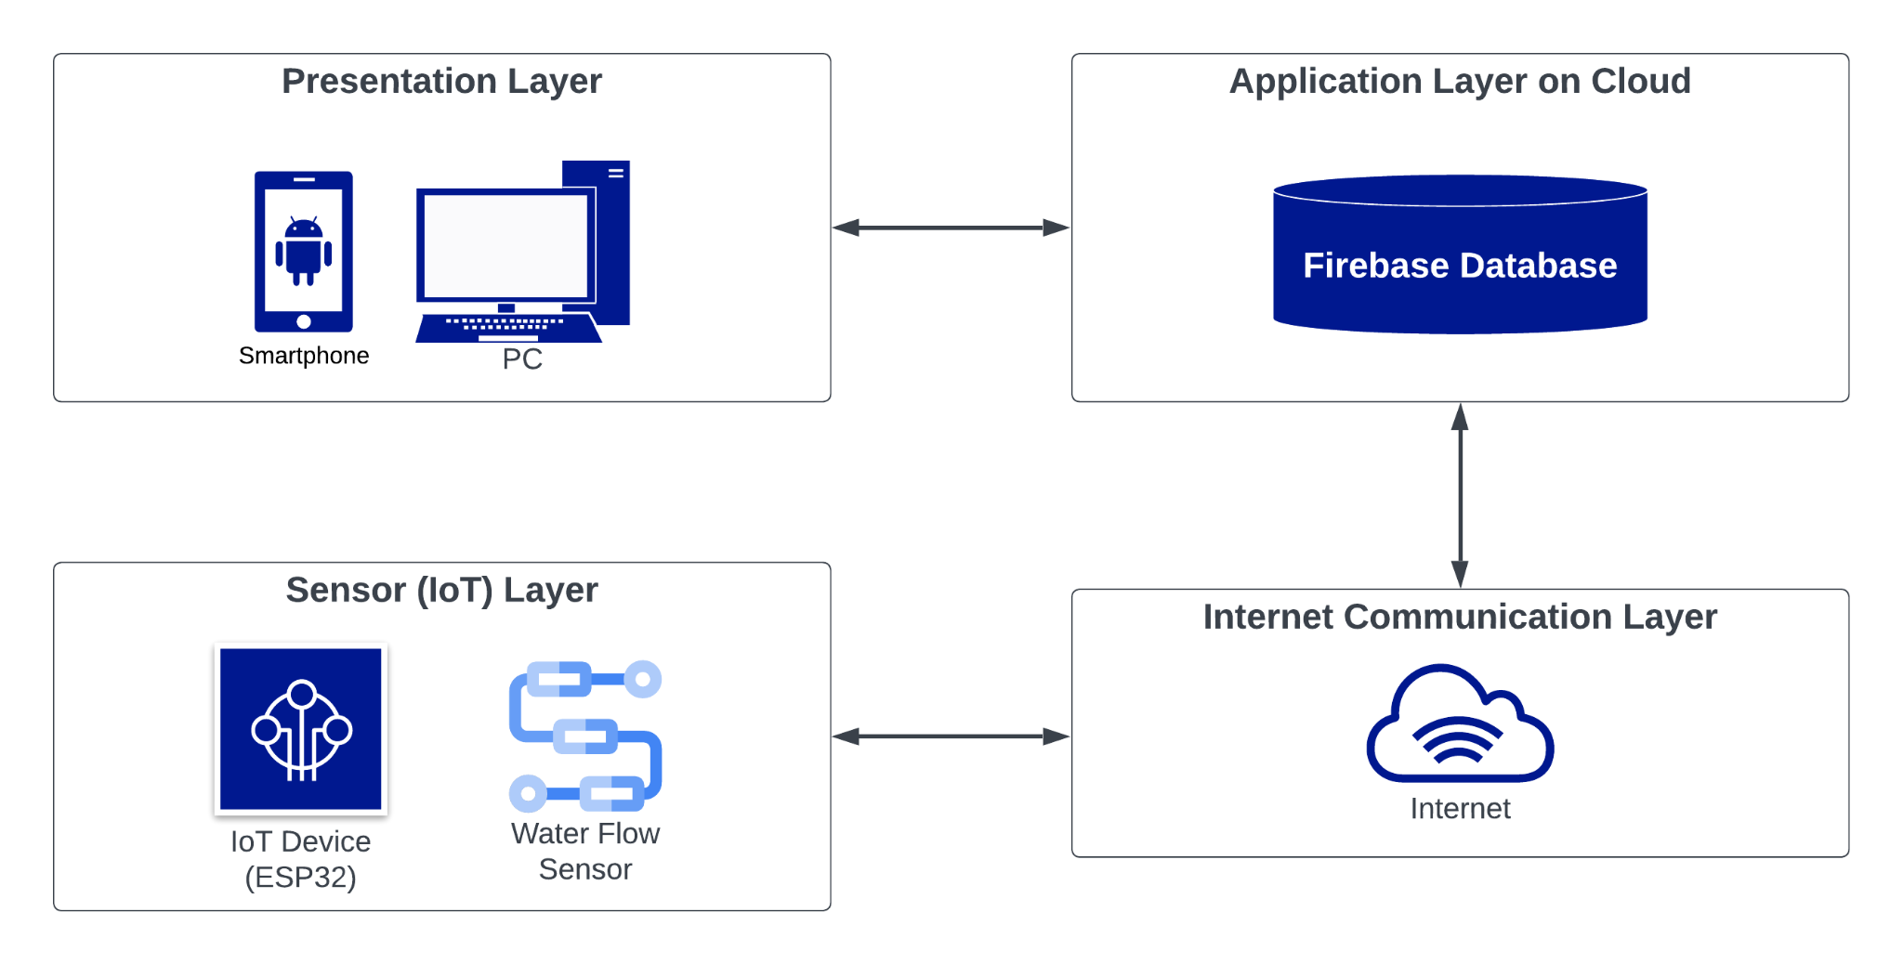

*Figure 1. Architecture Diagram of WaterWise+*

The WaterWise+ application architecture is elegantly composed of four distinct layers. The Presentation Layer encompasses the user interface, offering functionalities like authentication and water usage input and reporting, made seamless by Provider state management. The Application Layer, hosted on the cloud, leverages Firebase backend services for user management, data storage, and computation. The Internet Communication Layer ensures reliable and secure data exchange between the app, cloud services, and IoT devices. Finally, the Sensor (IoT) Layer consists of water usage sensors that collect and transmit real-time data, enabling users to monitor and optimize their water consumption efficiently.

The hardware used for the IoT to function and will make the project possible are; ESP8266, Water Flow Sensor, Jumper Wires, and a Breadboard. The ESP8266 is responsible for making our program and application run. These microcontroller modules are capable of executing code that controls various aspects of your IoT project, including data collection from sensors, data processing, communication with the internet, and more. The Water Flow Sensor is a device that measures the rate of water flow in a pipe or system. It is responsible for reading water flow data, while jumper Wires and Breadboard connect the different hardware devices used in our IoT project.

**USE CASE DIAGRAM**

The WaterWise+ Use Case Diagram encompasses two primary actors: the customers, who represent the end-users, and the provider, who assumes the role of administrator in managing these users. This diagram effectively delineates the core functionalities of the application, shedding light on the different interactions facilitated between these actors and the system.

*Figure 2: Use Case Diagram*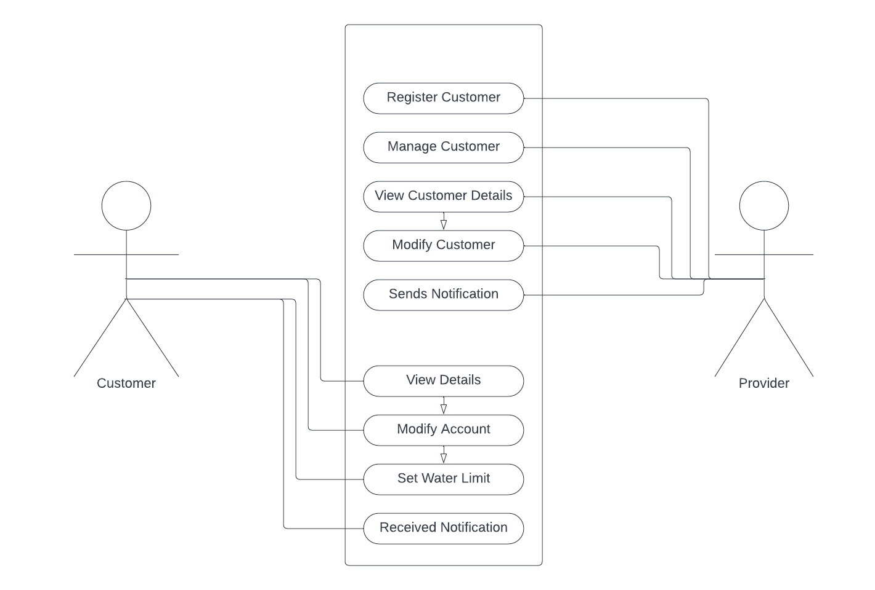

The provider, positioned as the system administrator, assumes a crucial role in managing the customer base. They possess the capabilities to not only register and view detailed customer profiles, but also to execute modifications to these profiles as needed. A significant function they perform is the dispatch of timely notifications to customers concerning various aspects of their water usage, such as water consumption, billing information, and adherence to predefined water limits.

The customers represent the user demographic of the application, with their interactions managed by the provider. The application empowers customers to monitor their water consumption in real-time, offering a transparent insight into their usage patterns. It enables them to set a custom water limit, aiding in more conscious and efficient water use. The system also facilitates access to both past and current water consumption records.

Additionally, customers possess the ability to modify their account details, such as updating their profile information. A noteworthy feature of the system is the provision for receiving notifications. This feature is activated when customers exceed their predetermined water limit, or when it's time for bill payment, thereby ensuring timely updates and promoting efficient water usage.

**USE CASE NARRATIVES**

The WaterWise+ Use Case Narratives explain the targeted process to achieve a particular goal. They provide further details on how each Use Case operates within the broader context of the application. In doing so, these narratives offer essential insight into the integral roles each Use Case plays in the successful operation of the application.

**Monitor and Assess Water Consumption Use Case**

This table shows how the provider monitors and assesses the real-time water consumption of each customer.

| Use Case | UC 1: Monitor and Assess Water Consumption | |
| --- | --- | --- |
| Actors | Provider | |
| Type | Essential | |
| Precondition | The provider is logged into the application and has navigated to the real-time water consumption monitoring dashboard, and has complete control over its customers | |
| Post-condition | The provider successfully views and assesses the current water usage per household. | |
| FLOW OF EVENTS | | |
| Actor Action | | System Response |
| 1. The provider views the real-time water consumption of a customer. | | 1. The system fetches the relevant data from IoT devices and displays it on the dashboard. |

*Table 1: Monitor and Assess Water Consumption Use Case Narrative*

**Manage Customer’s Water Bills Use Case**

This table displays how the provider admin manages customer’s water bills, including making and viewing billing statements.

| Use Case | UC 2: Manage Customer’s Water Bills | |
| --- | --- | --- |
| Actors | Provider | |
| Type | Essential | |
| Precondition | The admin is logged into the application and has selected a customer account. | |
| Post-condition | The admin successfully manages the water bills of the selected customer. | |
| FLOW OF EVENTS | | |
| Actor Action | | System Response |
| 1. The admin views or creates a new billing statement for a customer. | | 1. The system retrieves or updates the relevant billing data and displays it. |
| ALTERNATIVE SCENARIOS | | |
| 1. A new bill is created for a customer. | | 1. The system generates a new billing statement, updates the database and notifies the customer. |

*Table 2: Manage Customer’s Water Bills Use Case Narrative*

**Modifies Customer’s Status Use Case**

This table displays how the provider modifies the customer’s status to active, inactive, or restricted.

| Use Case | UC 3: Modifies Customer’s Status | |
| --- | --- | --- |
| Actors | Provider | |
| Type | Essential | |
| Precondition | The admin is logged into the application and has selected a customer account. | |
| Post-condition | The admin successfully modifies the status of the selected customer. | |
| FLOW OF EVENTS | | |
| Actor Action | | System Response |
| 1. The provider views and sets the status of a customer, depending on the accounts billing and inactivity status. | | 1. The system updates the status data and sets the account on hold. |
| ALTERNATIVE SCENARIOS | | |
| 1. A status is set for the customer. | | 1. The system updates the account status depending on the set condition. |

*Table 3: Manage Customer’s Water Bills Use Case Narrative*

**Set Water Consumption Limit Use Case**

This table shows how the customer sets a predetermined water consumption or cost limit.

| Use Case | UC 4: Set Water Consumption Limit | |
| --- | --- | --- |
| Actors | Customer | |
| Type | Essential | |
| Precondition | The customer is logged into the application and has navigated to the settings. | |
| Post-condition | The customer has successfully set a predetermined water consumption. | |
| FLOW OF EVENTS | | |
| Actor Action | | System Response |
| 1. The customer sets a predetermined water consumption. | | 1. The system updates the limit in the database and applies it to the customer's account. |
| ALTERNATIVE SCENARIOS | | |
| 1. Customer attempts to set a limit beyond the allowed range. | | 1. The system rejects the limit and prompts an error message. |

*Table 4: Set Water Consumption Limit Use Case Narrative*

**Set Budget Limit Use Case**

This table outlines how the customer sets a budget limit for their water usage.

| Use Case | UC 5: Set Budget Limit | |
| --- | --- | --- |
| Actors | Customer | |
| Type | Essential | |
| Precondition | The customer is logged into the WaterWise+ application and has accessed the settings. | |
| Post-condition | The customer has successfully set a budget limit for their water consumption. | |
| FLOW OF EVENTS | | |
| Actor Action | | System Response |
| 1. The customer sets a budget limit for their water consumption. | | 1. The application updates the budget limit in the database and applies it to the customer's account. |
| ALTERNATIVE SCENARIOS | | |
| 1. The customer attempts to set a budget limit beyond the allowed range. | | 1. The application rejects the budget limit and displays an error message, prompting the customer to choose a valid budget value. |

*Table 5: Set Water Consumption Limit Use Case Narrative*

**View Water Billing Statement**

This table shows how the customer sets a predetermined water consumption or cost limit.

| Use Case | UC 6: View Water Billing Statement | |
| --- | --- | --- |
| Actors | Customer | |
| Type | Essential | |
| Precondition | The customer is logged into the WaterWise+ application and navigates to the "Billing" section | |
| Post-condition | The customer has viewed their current and previous water billing statements. | |
| FLOW OF EVENTS | | |
| Actor Action | | System Response |
| 1. The customer navigates to the "Billing" section. | | 1. The system displays the available options. |
| ALTERNATIVE SCENARIOS | | |
| 1. The customer chooses to view current or previous billing statements. | | 1. The system retrieves the relevant billing data from the database and displays it to the customer. |

*Table 6: View Water Billing Statement Use Case Narrative*

**ACTIVITY DIAGRAM**

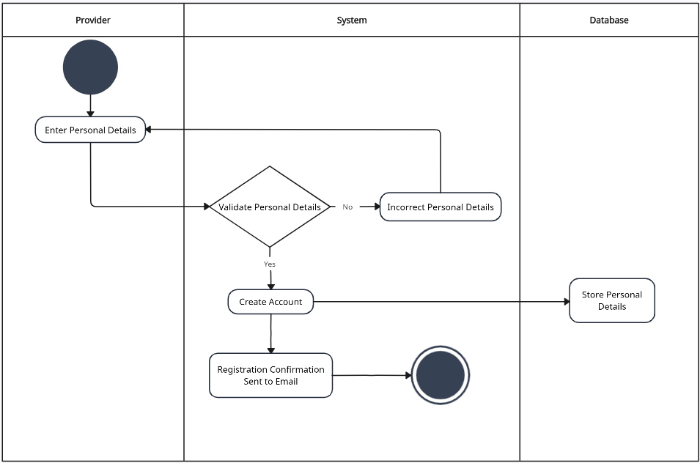

*Figure 3. Customer Registration Activity Diagram*

In this process, the provider registers a new customer by entering the customer’s personal details. If the personal details are validated then the registration data is saved in the database, creating a new customer record. This secure and efficient registration process is essential to onboard new customers to the WaterWise+ app and enable them to utilize its features for real-time water consumption monitoring and management.

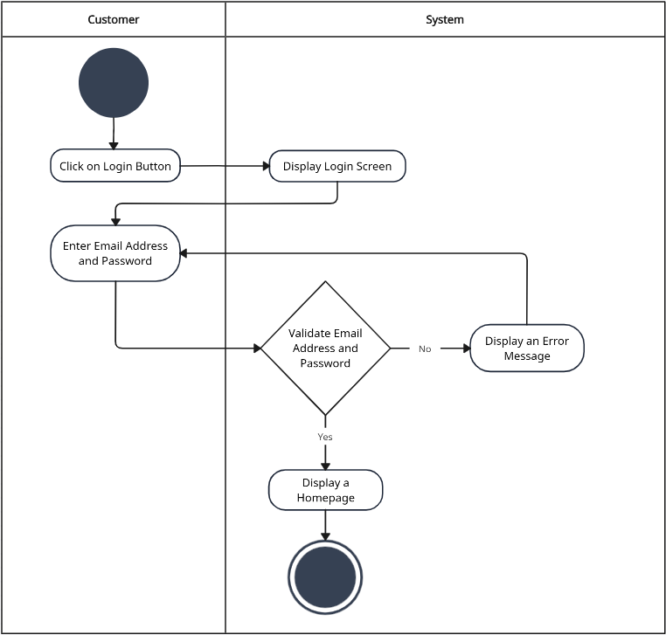

*Figure 4. Login Activity Diagram*

This figure demonstrates when a user attempts to log in, the system cross-references the entered credentials with the stored data in the database to verify the user's identity and determine whether access should be granted. If the credentials match, the user is authenticated, and if not, access is denied. This secure and efficient login process is essential to ensure that only authorized users can access the WaterWise+ app and its real-time water consumption monitoring features.

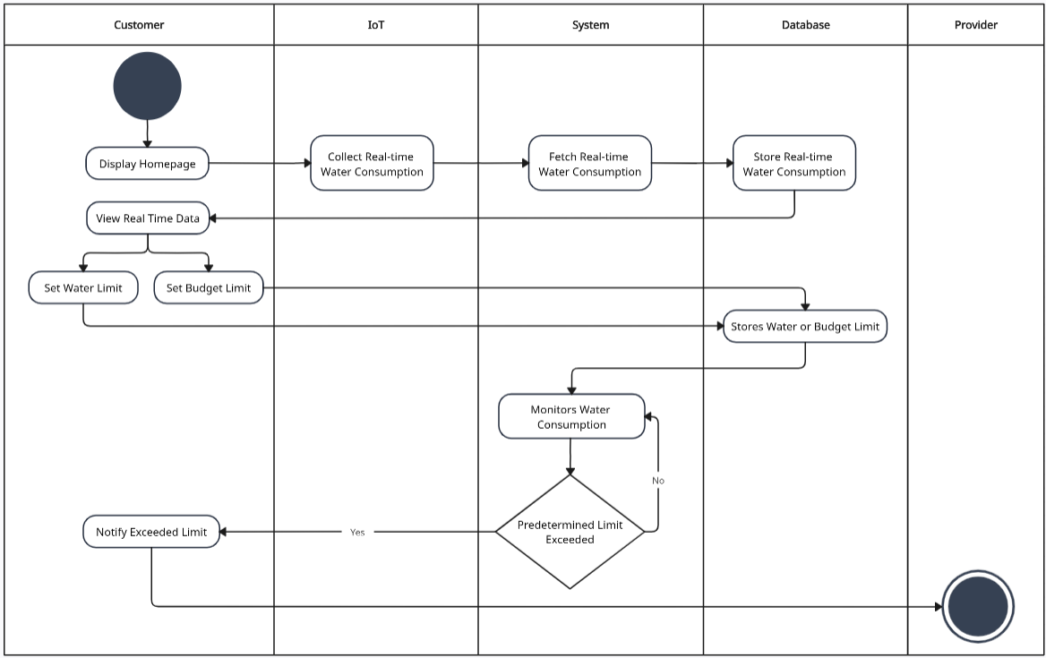

*Figure 5. Real-time Water Consumption Monitoring with Water Consumption Limit and Budget Preferences Activity Diagram*

In this real-time water consumption monitoring activity, the "System" establishes a connection with the "IoT" devices, such as water flow sensors, installed in the customer's household. Once connected, the system fetches real-time water consumption data through collecting it from the IoT devices, continuously monitoring water usage. It then stores the data and displays the real-time consumption data on the customer's screen, providing them with immediate insights into their current water usage in cubic meters. The customers can set their water consumption limit or budget limit preferences and notifies when their predetermined limit is exceeded.

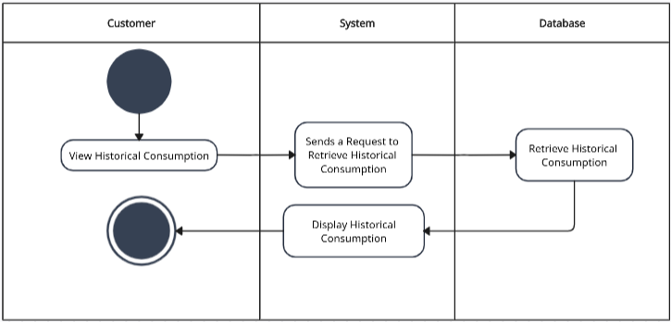

*Figure 6. View Historical Water Consumption Activity Diagram*

In this activity, the "Customer" initiates the process by selecting the "View Historical Consumption" option from the WaterWise+ app. The "System" then sends a request to the "Database" to retrieve the historical water consumption data associated with the customer's account. Once the data is retrieved, the "System" displays it on the customer's screen, allowing them to gain insights into their past water usage patterns.

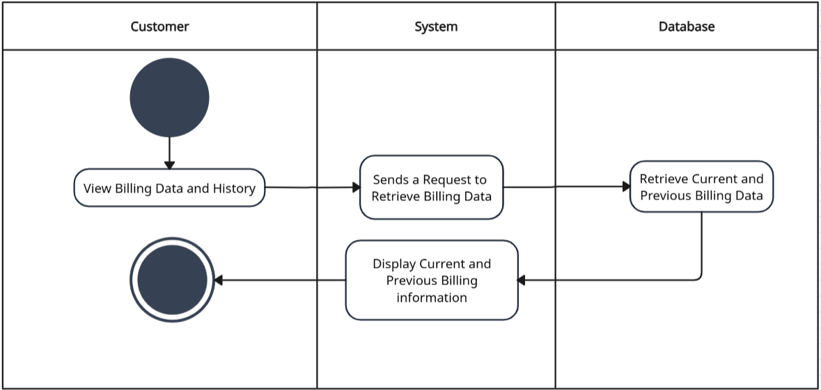

*Figure 7. View Billing Statement and History Activity Diagram*

The View Billing activity allows the "Customer" to access and review their billing history using the WaterWise+ application. When the customer initiates the process, the "System" retrieves the relevant billing data from the "Database," which includes current and past billing statements. The retrieved billing information is then presented on the customer's screen in a user-friendly format. The customer can interact with the billing information, such as exploring past statements, reviewing specific details, or selecting a particular billing period for more in-depth analysis. This activity provides customers with transparency and control over their billing records, enabling them to monitor their water consumption patterns, track changes in usage, and stay informed about their billing history. WaterWise+ offers easy access to billing information that creates positive customer experience and promotes responsible water usage practices.

**UML CLASS DIAGRAM**

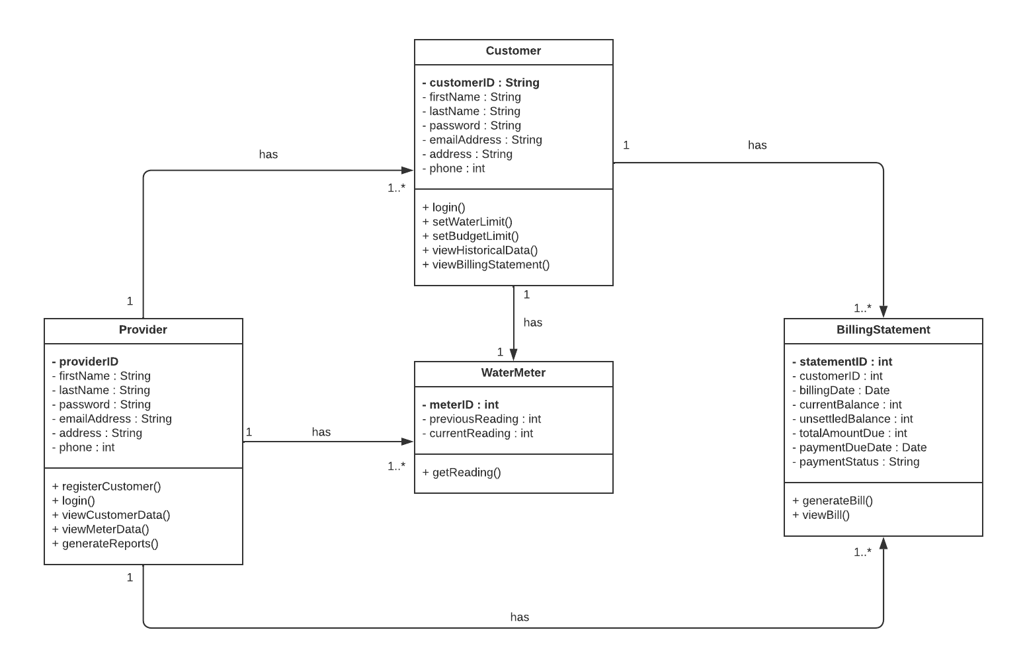

*Figure 8. WaterWise+ Class Diagram*

The UML Class Diagram for WaterWise+ depicts the key classes and their relationships, enabling real-time water consumption monitoring and billing for both customers and providers. The WaterWise+ application revolves around four primary classes: Customer, WaterMeter, BillingStatement, and Provider. The Customer class represents users of the app, granting them access to functionalities such as registration, login, and viewing historical water consumption data. Each customer is associated with a dedicated WaterMeter that records real-time water usage, while BillingStatement captures the details of billing statements generated based on individual consumption. Providers, represented by the Provider class, possess privileged access and can log in to the system. They manage multiple customers, water meters, and billing statements, providing comprehensive oversight and reporting capabilities. The Class Diagram's relationships illustrate the interactions between classes, enabling seamless communication and efficient water management for all users.

**USER INTERFACE AND USER EXPERIENCE DESIGN**

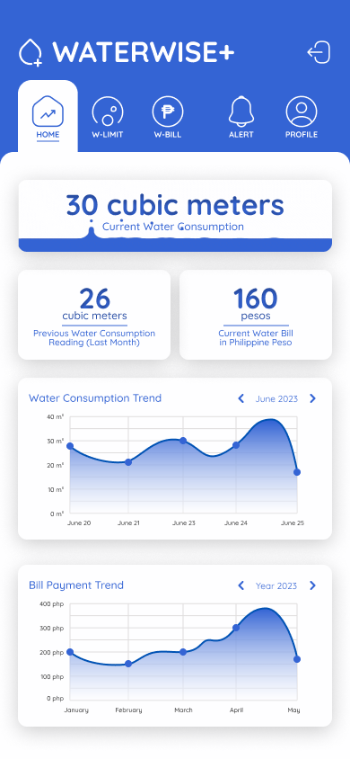

*Figure 9. Customer’s Homepage Screen*

The homepage of WaterWise+ provides users with real-time information on their current water consumption in cubic meters and displays the previous reading for tracking usage patterns. Users can easily view their current water bill in Philippine peso, enabling them to manage their expenses effectively. Additionally, a graphical representation of water consumption and billing history trends offers valuable insights for promoting water conservation and efficient usage.

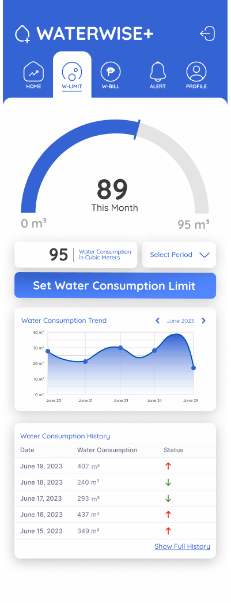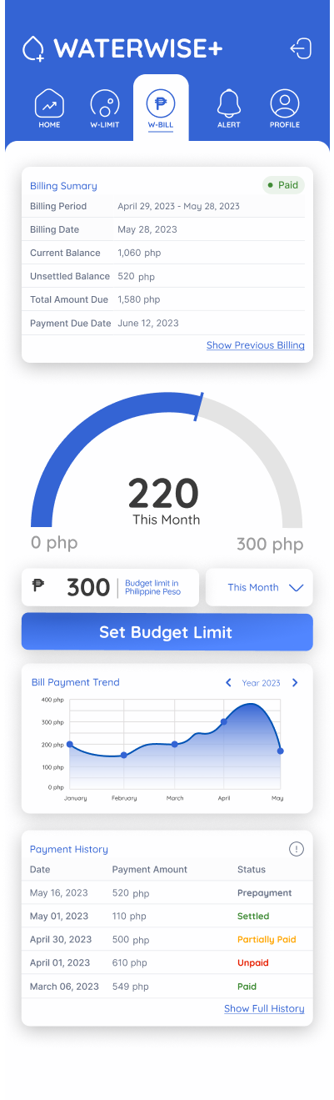

*Figure 10. Customer’s Water Data and Water Bill Screens*

The Water Data and Water Bill screen in WaterWise+ allows users to set a personalized water consumption limit or budget limit, empowering them to manage their water usage based on conservation goals and financial considerations. The screen also provides a comprehensive history of water consumption and billing data, presented in both tabular and graphical formats. Users can track their consumption trends over time, enabling them to make informed decisions about their water usage and promote responsible water management.

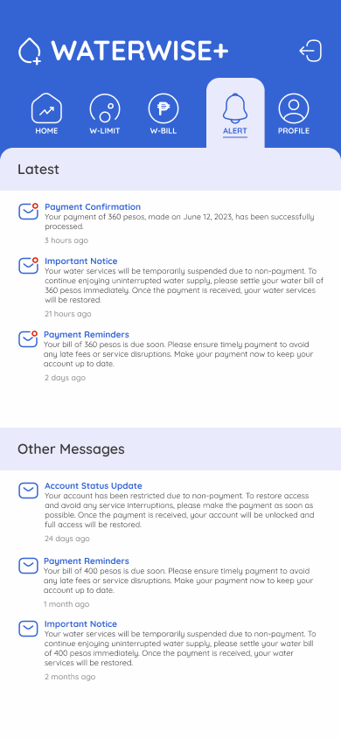

*Figure 11. Customer’s Notification Screen*

The Notification Screen in WaterWise+ provides real-time alerts and notifications to users regarding their water consumption and billing. Users receive timely notifications when they exceed their set water consumption limit or budget limit, helping them stay conscious and efficient in their water usage. Additionally, the screen ensures that users are well-informed about their water usage and billing status, promoting water conservation and financial awareness.

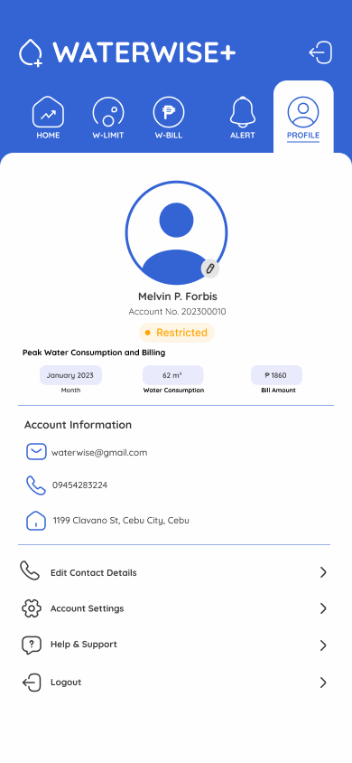

*Figure 12. Customer’s Profile Screen*

In the Profile Screen of WaterWise+, customers can access and manage their personal details, as well as view their account status. The status indicates whether the account is currently Active, Inactive, or Restricted. This feature helps users stay informed about their account status and any relevant updates from the service provider. By having easy access to this information, users can promptly address any account-related issues and ensure that their water monitoring and billing services are functioning as expected. Customers can not only access and manage their personal details and account status but also view their peak water consumption and billing.

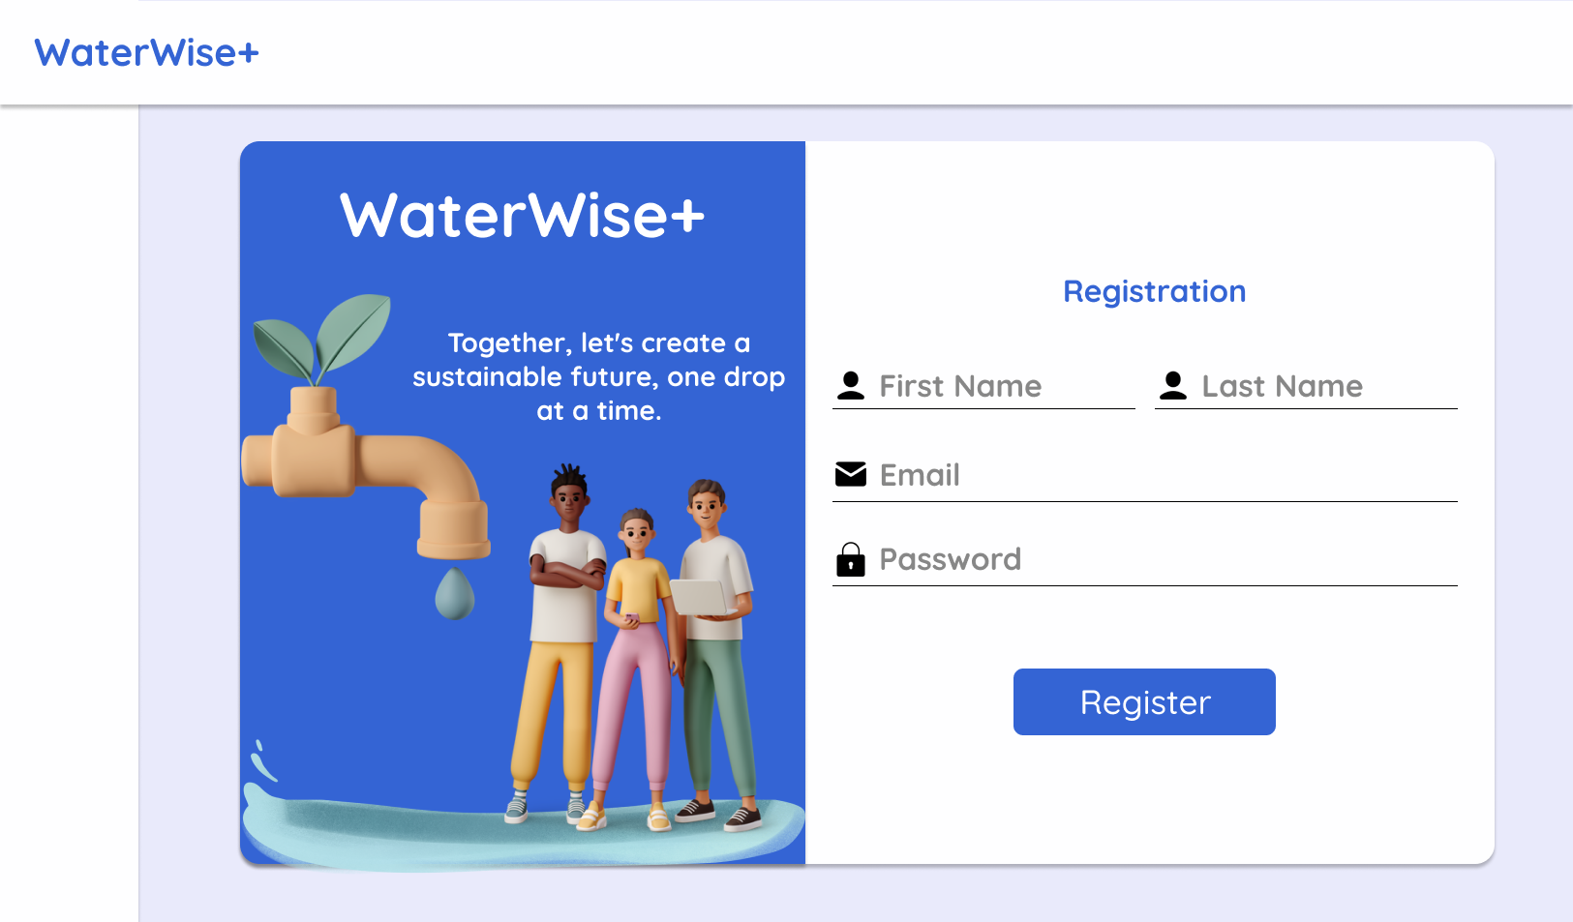

*Figure 13. Provider’s User Registration Screen*

The Provider's User Registration Screen offers a streamlined and secure registration process for water service providers. This screen serves as the gateway for adding new customers to the WaterWise+ application.

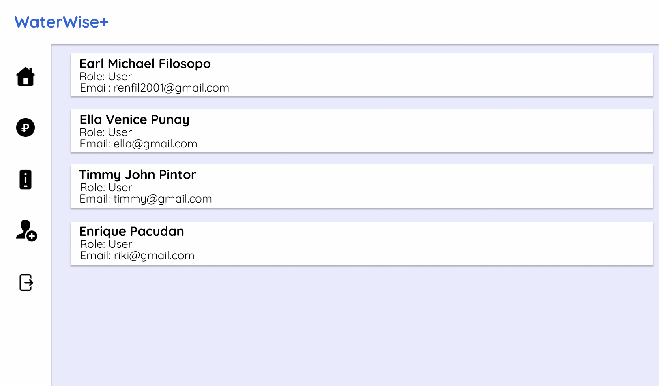

*Figure 14. Provider’s List of Customer Screen*

The Provider's List of Customer Screen is an overview of all registered customers within the WaterWise+ system. Through this interface, providers can easily access and manage a list of customers, including their personal details and relevant information, which enhances provider efficiency, enabling quick identification and selection of specific customer profiles.

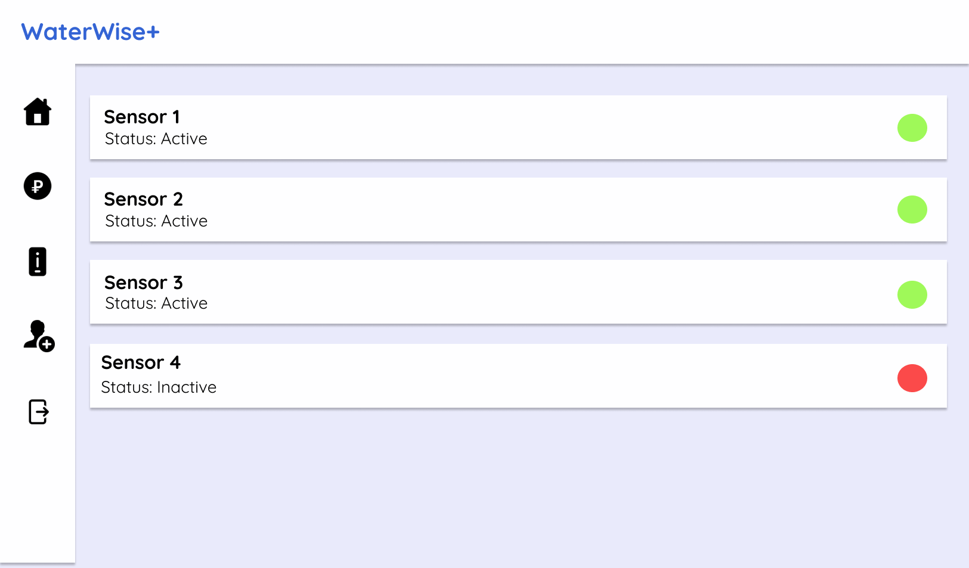

*Figure 15. Provider’s IoT Devices’ Status Screen*

The Provider's IoT Devices' Status Screen provides a clear display of the status of IoT devices or sensors associated with water monitoring. This screen offers real-time information on the activation status of each IoT sensor, indicating whether they are currently active or inactive. This visual representation allows providers to assess the operational status of their IoT devices, enabling prompt troubleshooting or maintenance actions when needed. This interface enhances the monitoring and management of IoT devices, contributing to efficient water consumption tracking and resource management.

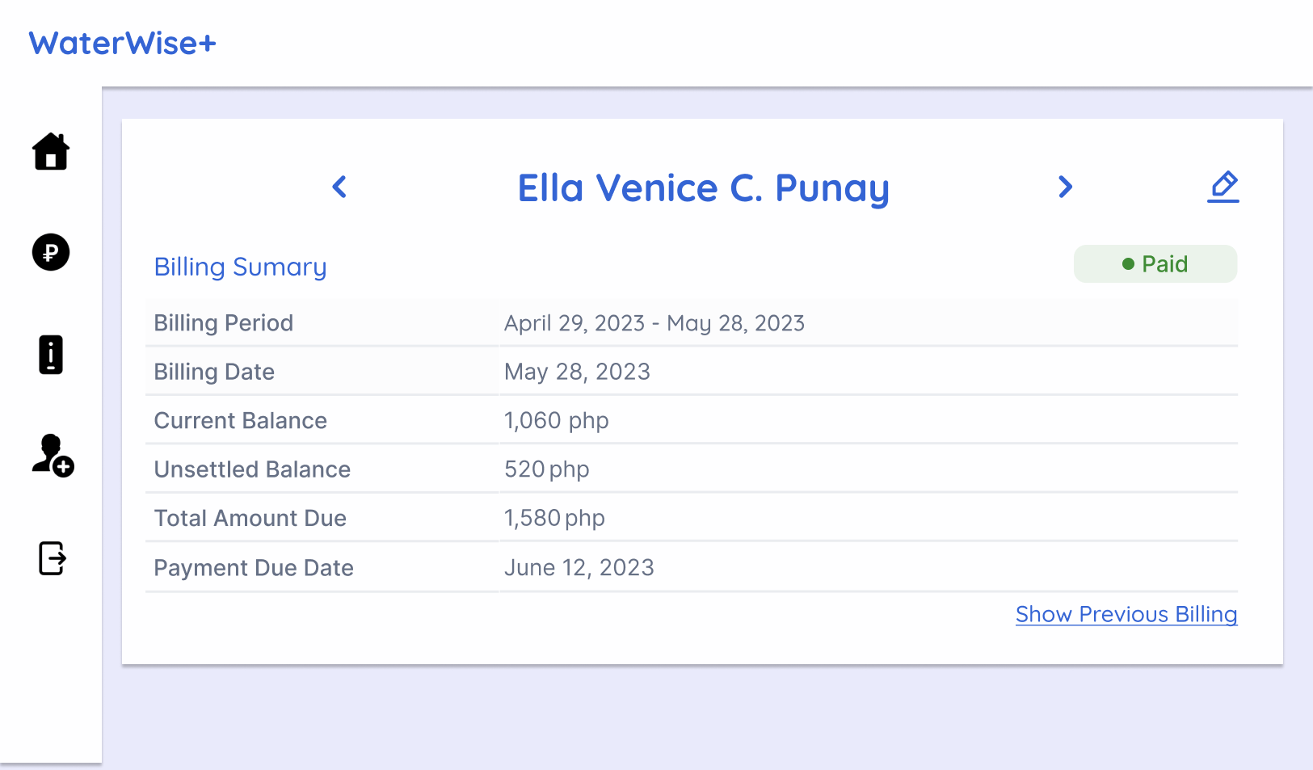

*Figure 16. Provider's Customer Water Billing Statement and Information Screen*

The Provider's Customer Water Billing Statement and Information Screen serves as a platform for providers to generate, view, and modify water billing statements and associated customer information for a specific billing cycle. Additionally, providers have the flexibility to edit customer information as necessary, ensuring accurate and up-to-date records. This screen streamlines the billing process, enhances data accuracy, and facilitates effective communication between providers and customers regarding water consumption and billing details.

**REFERENCES**

| [1] | M. J. Mudumbe and A. M. Abu-Mahfouz, "Smart water meter system for user-centric consumption measurement," *2015 IEEE 13th International Conference on Industrial Informatics (INDIN)*, Cambridge, UK, 2015, pp. 993-998, doi: 10.1109/INDIN.2015.7281870. |
| --- | --- |
| [2] | S. Basu, A. Ahmed, H. Pareek and P. K. Sharma, "Autonomous Water Flow Control And Monitoring System," *2022 Interdisciplinary Research in Technology and Management (IRTM)*, Kolkata, India, 2022, pp. 1-4, doi: 10.1109/IRTM54583.2022.9791534. Retrieved from https://ieeexplore.ieee.org/document/9791534 |
| [3] | H. Fuentes, D. Mauricio, "Smart water consumption measurement system for houses using IoT and cloud computing," *Environmental Monitoring and Assessment*, vol. 192, p. 602, 2020. Retrieved from https://doi.org/10.1007/s10661-020-08535-4 |
| [4] | E.B. Rizzo, F.A. Cousin, R.M. Lucca, & S.R. Lautenschlager, "Autonomous metering system for monitoring water consumption," *AQUA - Water Infrastructure, Ecosystems and Society*, vol. 70, no.6, pp. 797-810, 2021. Retrieved from https://doi.org/10.2166/aqua.2021.04 |
| [5] | “What is the internet of things (IOT)?,” What Is the Internet of Things (IoT)?. Retrieved from https://www.oracle.com/internet-of-things/what-is-iot/ |